# Location: <https://help.pentaho.com/Documentation/7.0/0D0/160/000>

### **Application Servers**

Servers to which you deploy Pentaho software must run one of these application servers:

* JBoss EAP 6.4.x
* Tomcat 7.0.x with Oracle Java 8.x
* Tomcat 8.0.x with Oracle Java 8.x (as shipped)

…

### **Java Virtual Machine**

Pentaho software requirements for Java Runtime Environment (JRE).

|  |  |
| --- | --- |
| Pentaho Software | Java Runtime Environment |
| All Pentaho software, except Pentaho Mobile App | Oracle Java 8 |

# Location: <https://help.pentaho.com/Documentation/7.0/0F0/0P0/020/0B0>

### **Prepare Your Linux Environment (Manual Installation)**

The location below should be “/usr/lib/jvm/java-8-oracle”

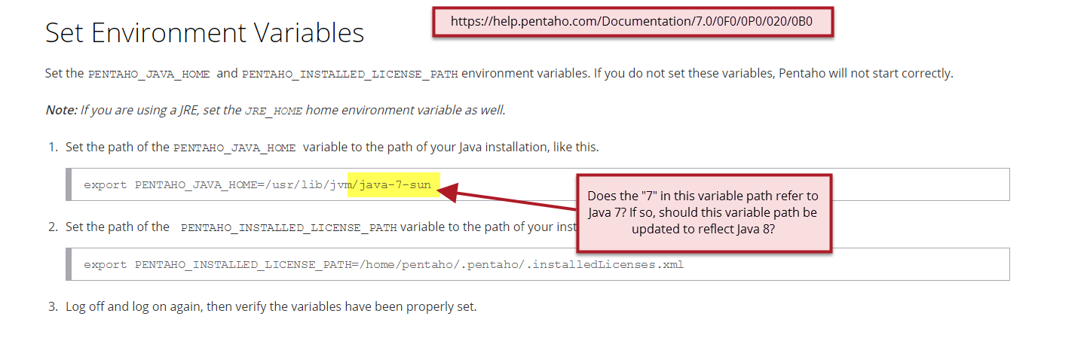

***Attaching email from 12/5:***

Yes please

**From:** Virginia Agnew <vagnew@pentaho.com>  
 **Date:** Monday, December 5, 2016 at 4:08 PM  
 **To:** David Kincade <dkincade@pentaho.com>  
 **Subject:** RE: DOC-3057 Tech Review -- JBoss EAP 6.4.x follow-up question

David,

A quick follow-up based on your comments on the case. Should the “with Oracle Java 8” phrase be added to JBoss EAP 6.4.x, as shown below?

Thanks!

Virginia

### **Application Servers**

Servers to which you deploy Pentaho software must run one of these application servers:

* JBoss EAP 6.4.x **with Oracle Java 8.x**
* Tomcat 7.0.x with Oracle Java 8.x
* Tomcat 8.0.x with Oracle Java 8.x (as shipped)

…